EDS ASSGINMENT
Sales Transactions Weekly Dataset
Analysis Report
Using NumPy and Pandas | UCI Machine Learning Repository

1. Introduction
Sales data analysis plays a crucial role in understanding customer behavior, product demand, and business performance. In this report, we analyze the Sales Transactions Weekly Dataset obtained from the UCI Machine Learning Repository using Python libraries NumPy and Pandas.

2. Dataset Source
The dataset was fetched using the ucimlrepo library:

from ucimlrepo import fetch_ucirepo

sales_transactions_weekly = fetch_ucirepo(id=396)

This dataset contains weekly sales data for multiple products across different time periods.

3. Dataset Description
- The dataset contains weekly sales transactions
- Each row represents a product
- Columns represent weekly sales (W0, W1, W2, ...)
- Target variable represents total or aggregated sales

Features:
- Weekly sales values (W0 through Wn)

Target:
- Total sales or classification (depending on dataset version)

4. Methodology
- Imported dataset using ucimlrepo
- Converted data into Pandas DataFrame
- Performed cleaning and inspection
- Applied NumPy and Pandas operations
- Generated insights

5. Problem Statements and Solutions
The following 20 analytical queries were applied to the dataset:

1. Total Sales Across All Weeks
X.sum().sum()

2. Average Weekly Sales
X.mean().mean()

3. Week with Highest Sales
X.sum().idxmax()

4. Week with Lowest Sales
X.sum().idxmin()

5. Product with Highest Total Sales
X.sum(axis=1).idxmax()

6. Product with Lowest Total Sales
X.sum(axis=1).idxmin()

7. Total Sales per Product
X.sum(axis=1)

8. Weekly Sales Trend
X.sum()

9. Standard Deviation of Sales
X.std().mean()

10. Median Weekly Sales
X.median().mean()

11. Top 5 Best-Selling Products
X.sum(axis=1).nlargest(5)

12. Bottom 5 Products
X.sum(axis=1).nsmallest(5)

13. Weeks with Sales Above Average
X.loc[:, X.mean() > X.mean().mean()]

14. Correlation Between Weeks
X.corr()

15. Products with Zero Sales Weeks
(X == 0).sum(axis=1)

16. Maximum Weekly Sale Value
X.max().max()

17. Minimum Weekly Sale Value
X.min().min()

18. Variance in Sales
X.var().mean()

19. Products with Consistent Sales (Low Std Dev)
X.std(axis=1).nsmallest(5)

20. NumPy Statistical Summary
import numpy as np
np.mean(X.values), np.median(X.values), np.std(X.values)

6. Key Insights
- Certain weeks show significantly higher sales, indicating seasonal demand.
- Some products consistently outperform others.
- A few products show irregular or zero sales, indicating low demand.
- Sales variability differs across products and weeks.

7. Conclusion
The analysis highlights how weekly sales patterns can provide valuable insights into product performance and demand trends. Using NumPy and Pandas, large datasets can be efficiently analyzed to support business decision-making.

8. References
- UCI Machine Learning Repository
- NumPy Documentation
- Pandas Documentation

9. Code

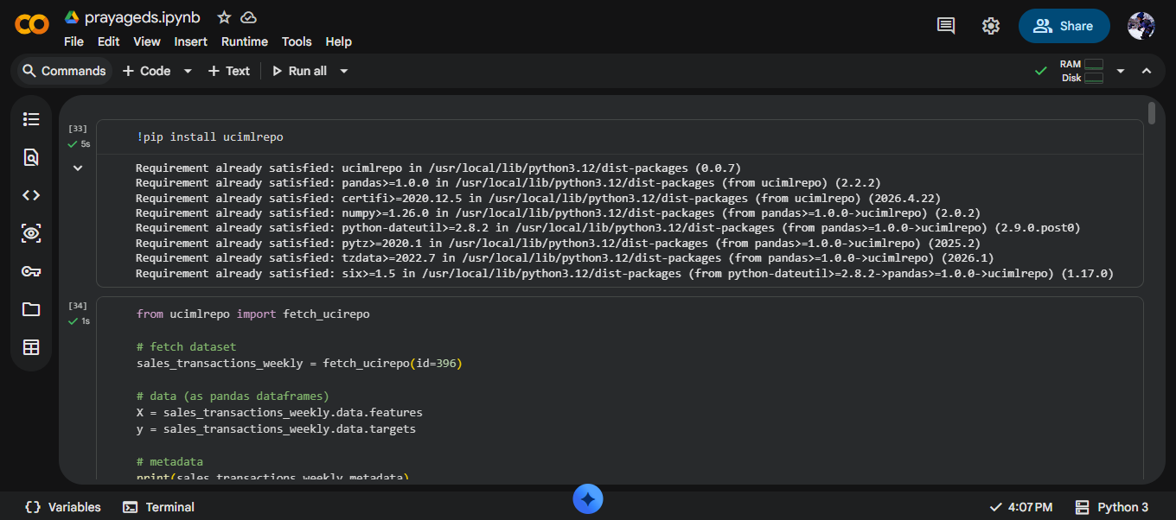

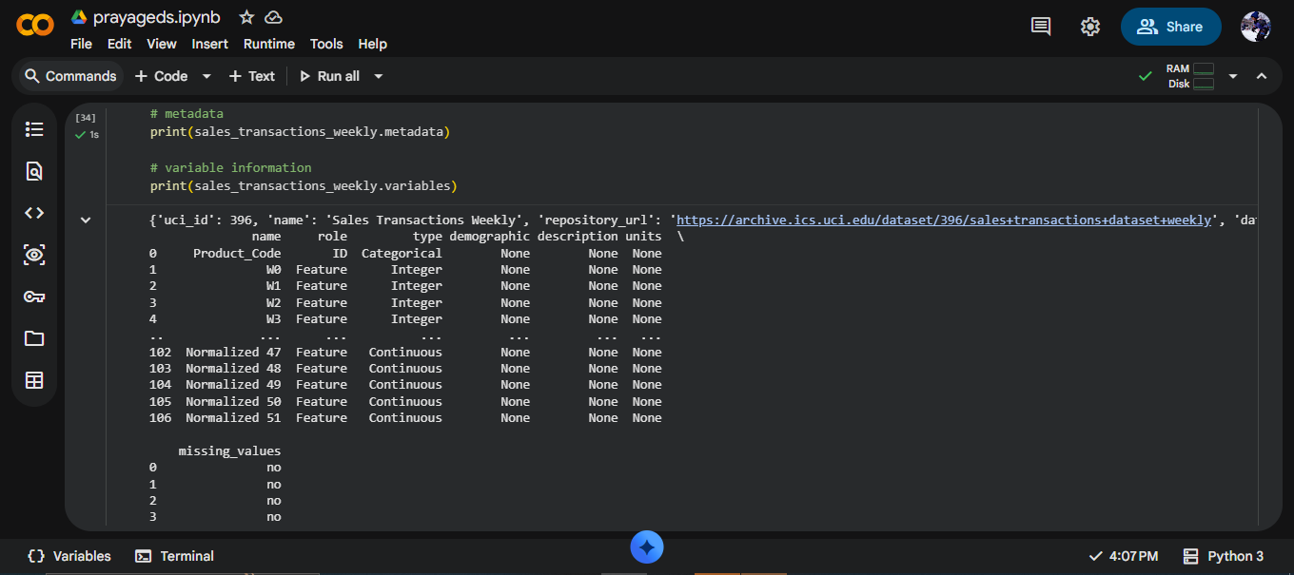

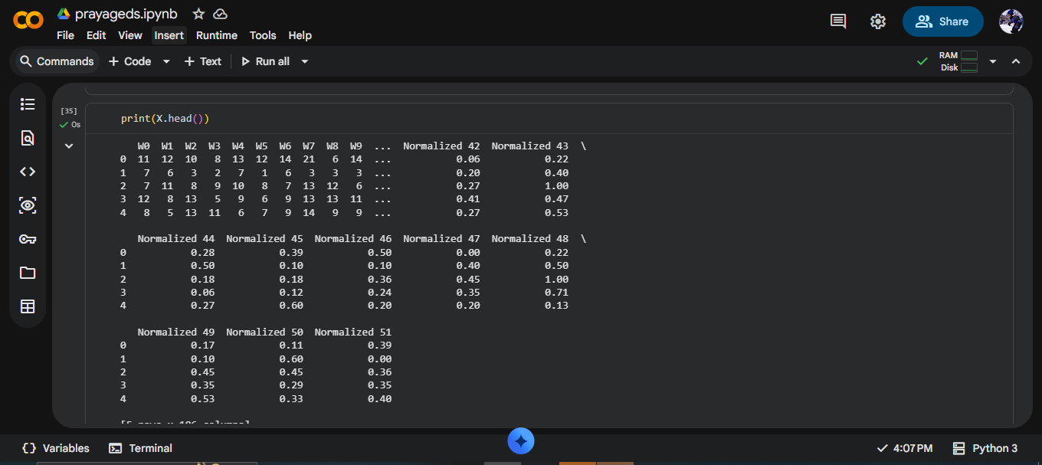

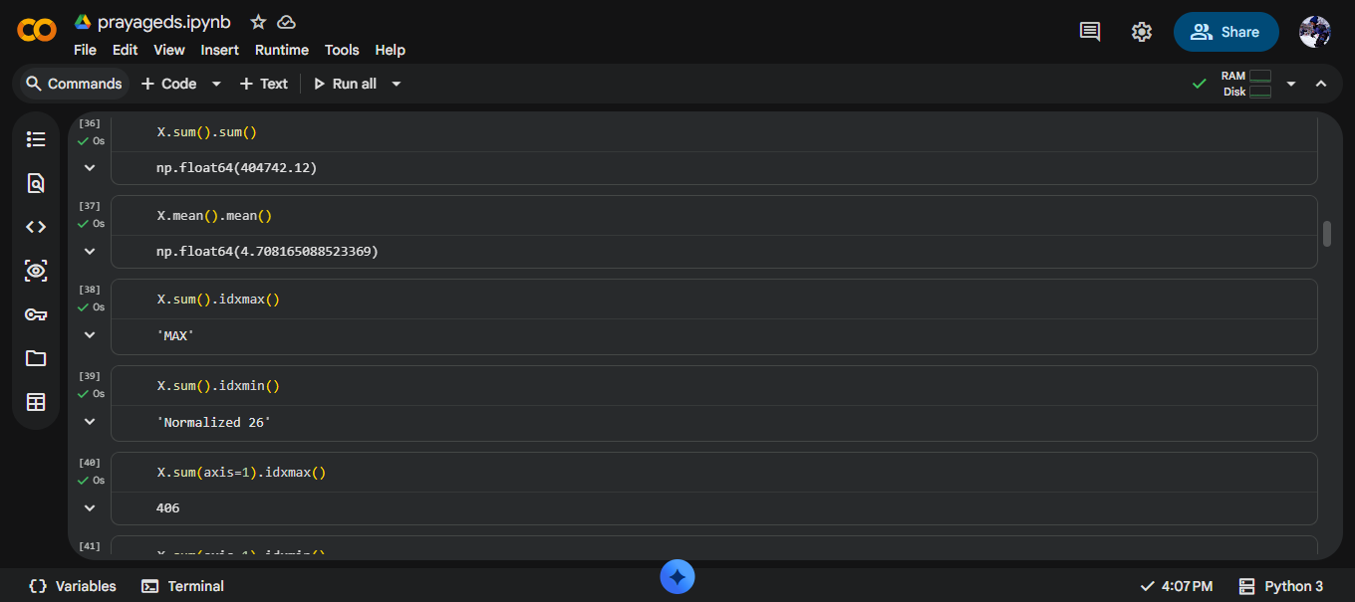

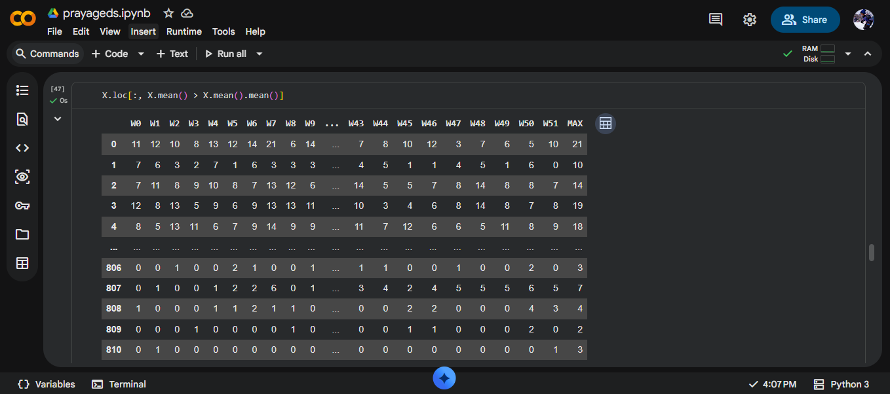

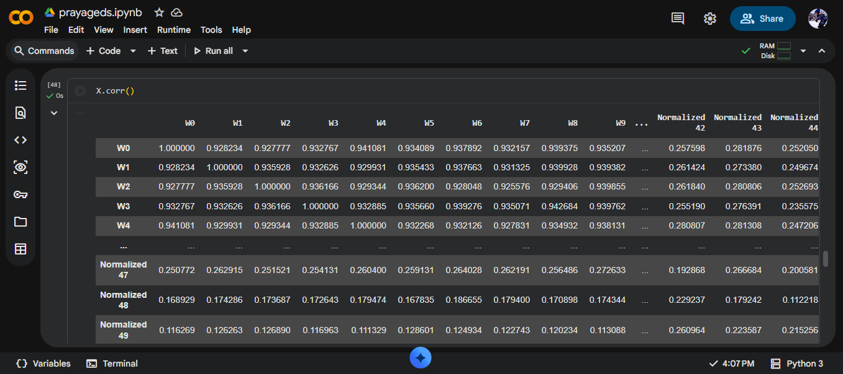

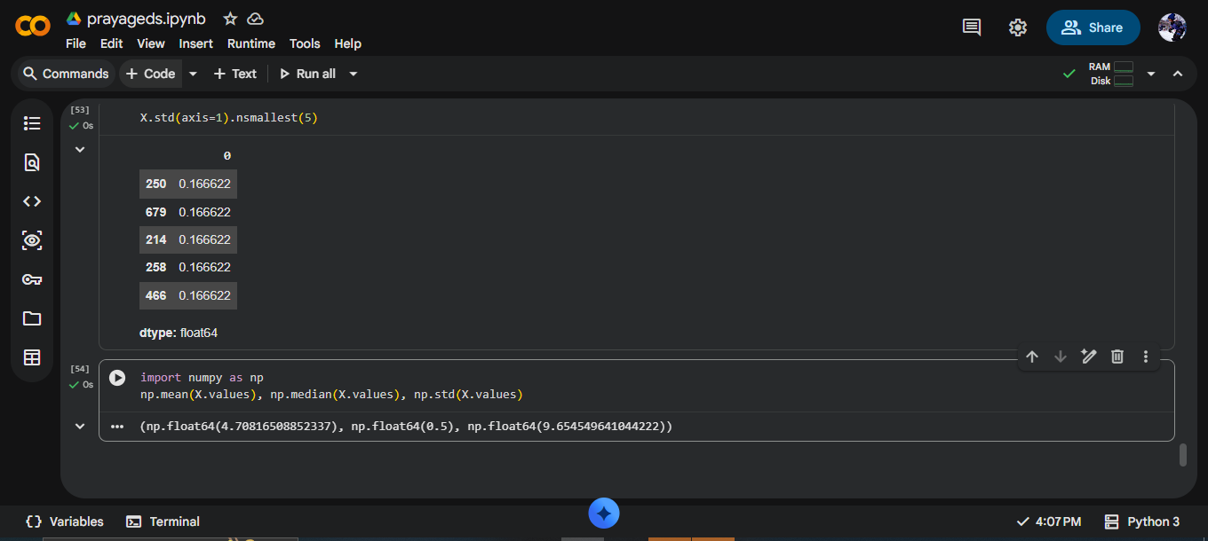

10. Link

https://colab.research.google.com/drive/1U8ZC3z-y5bcB_k8F47qLPHu0KmvPARSH?usp=sharing#scrollTo=oKlt0Zs7aO4E

REPORT BY-
NAME: PRAYAG PAWAR
PRN: 202501090002
BATCH: M11

